HADOOP EXPERIMENTS

EXP-1: Install Hadoop 2x and configure the Name Node and Database.

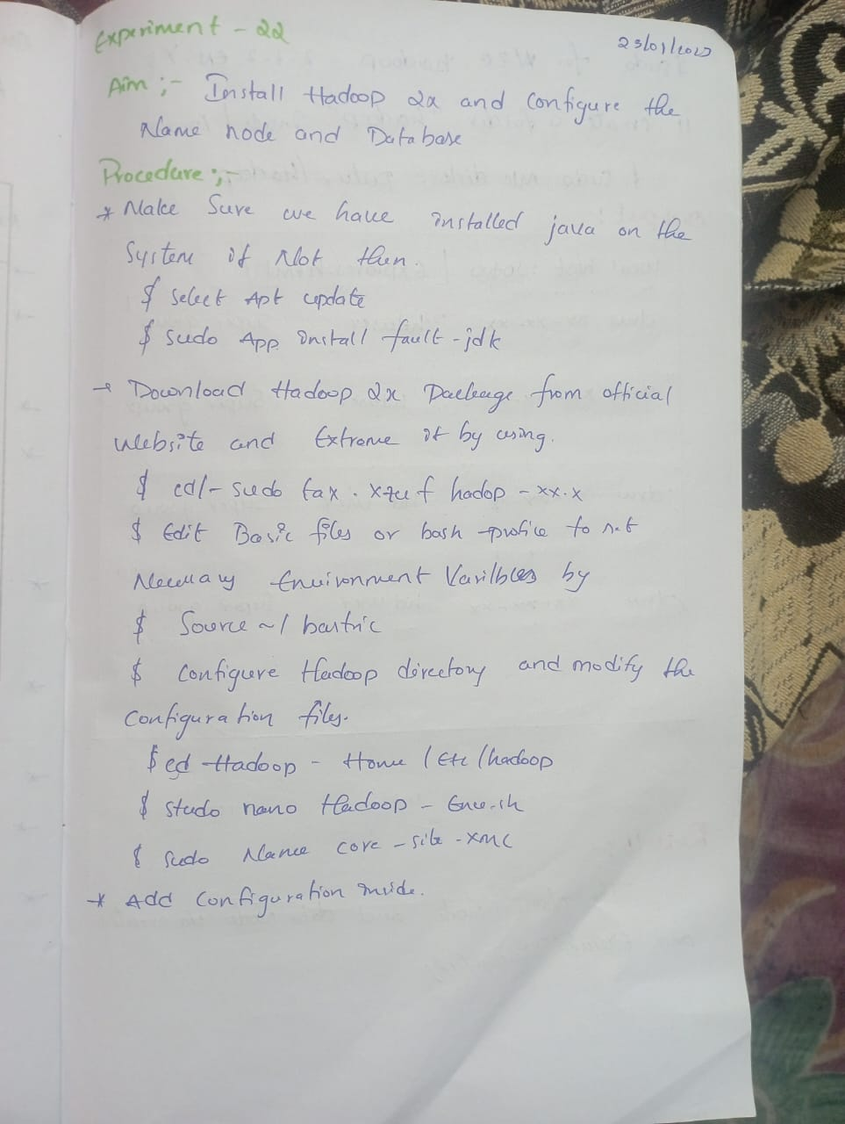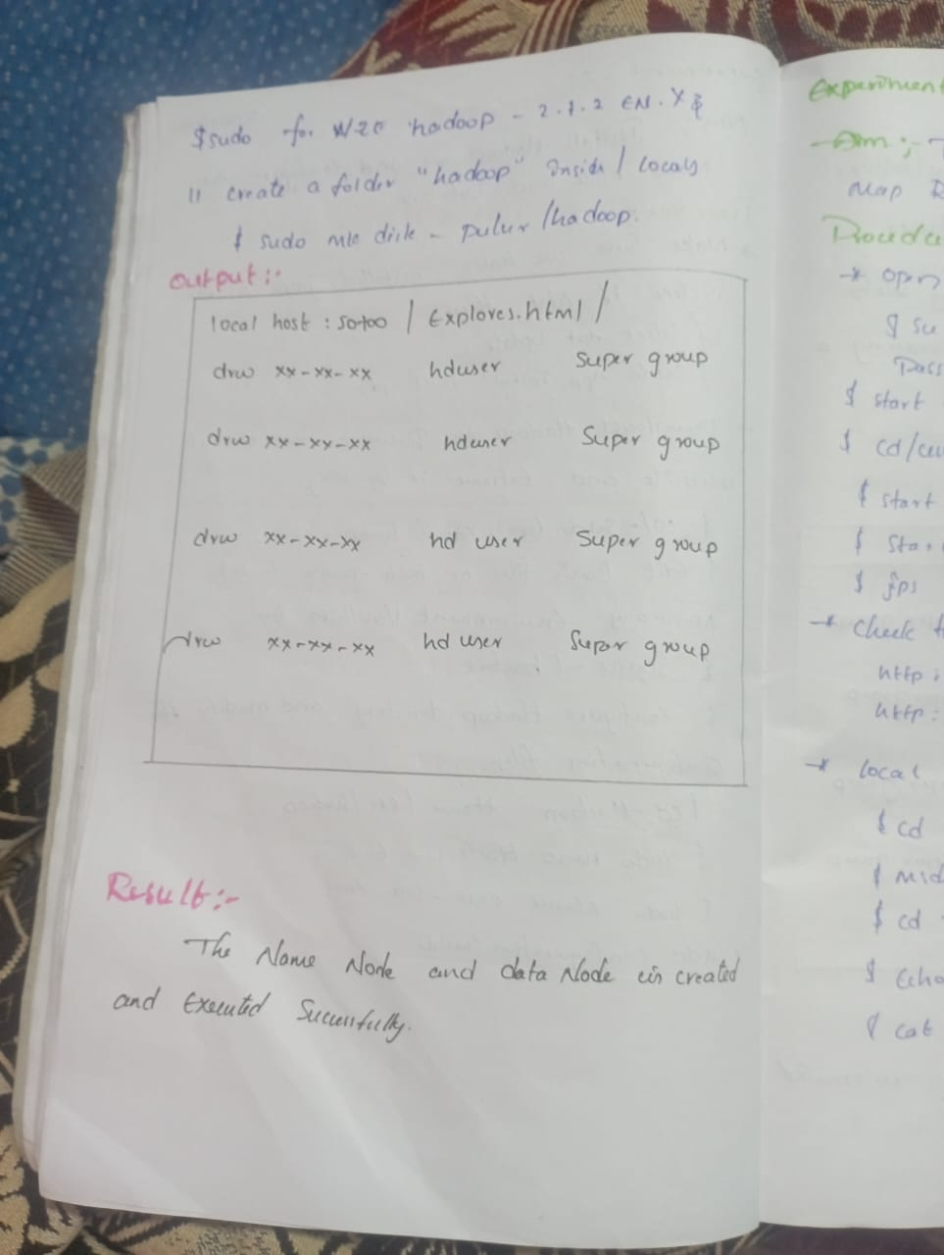

EXP-2: To create a Hadoop 2x and test the Map Reduce Platform with Hadoop.

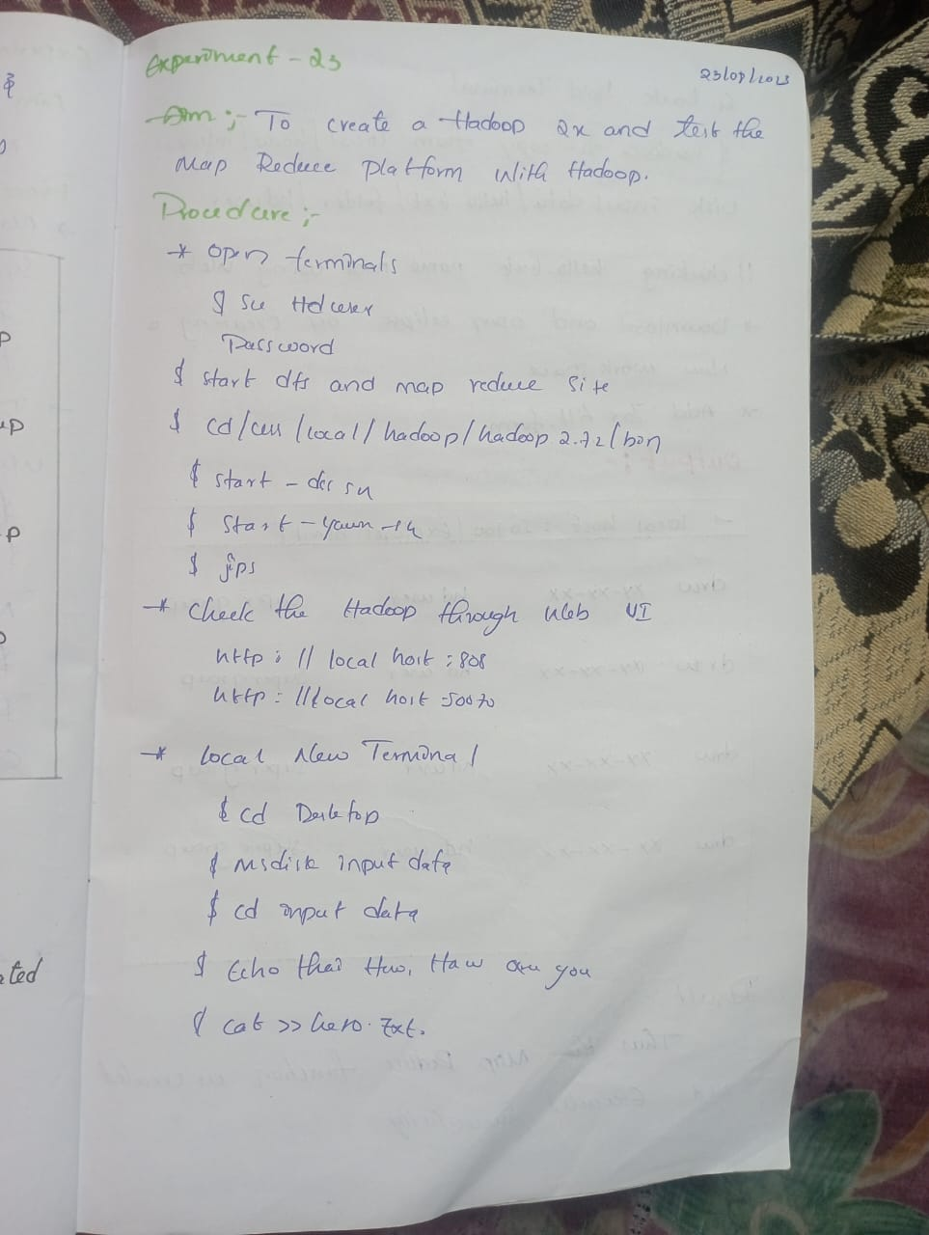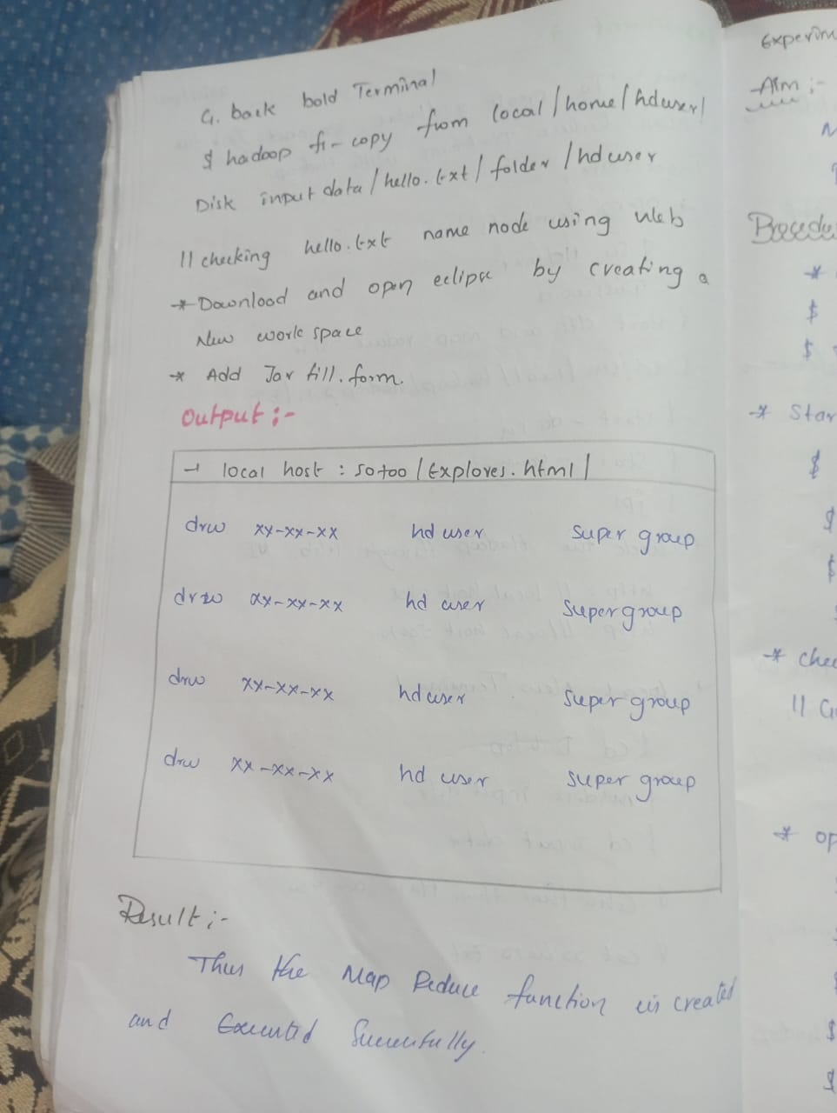

EXP-3: Launch the Hadoop 2x and Perform Map Reduce Program for a word count Problem. 